

VIEWPT VR180 Cam Quick Operation

Instructions VIEWPT VR180 Cam

快速操作说明

（型号：Realia）

固件版本：1.8.9

深圳视点创新科技有限公司

深圳市龙岗区坂田街道吉华路489号乐荟科创中心13栋A座4层A1

A1, 4th Floor, Block A, Building 13, Lehui Science and Technology Innovation Center, No. 489 Jihua Road, Bantian Street, Longgang

目录

Contents

● 相机概述 1

Camera Components Overview



● 如何使用VIEWPT CAM拍摄VR180视频 13

How to Shoot VR180 Videos with VIEWPT Cam?

● 如何使用VIEWPT CAM在VR180中进行直播 21

How to Live Stream in VR180 with VIEWPT Cam？

● 了解更多关于VIEWPT CAM中的UVC功能的信息 29

Get to Know More about UVC Function in VIEWPT CAM

● 如何使用VIEWPT CAM拍摄VR180或3D格式的照片 33

How to Take VR180 or 3D Photos with VIEWPT CAM?

**正面和背面 [Front and Back]**

***相机概述 [Camera Components Overview]***

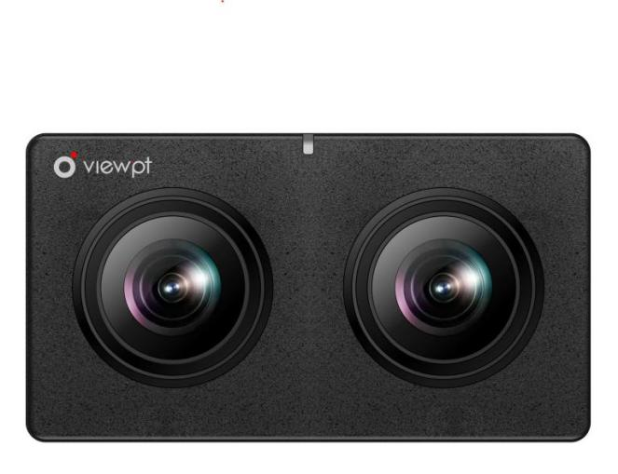

**10**

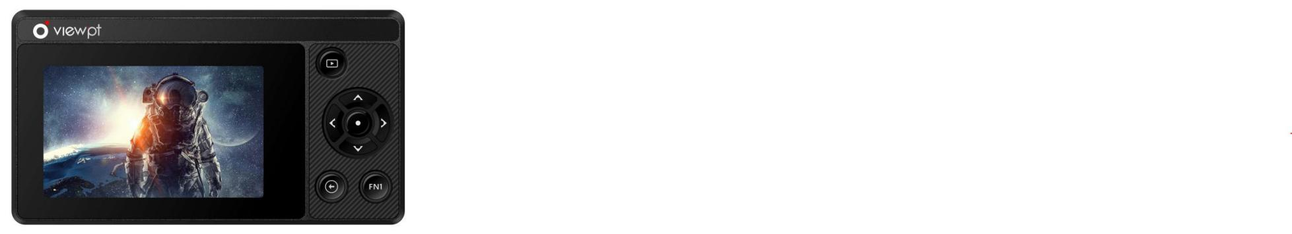

**1**

**2**

**3**

**4**

**9**

**7**

**8**

**5**

**6**

### **①** **Album Button** 【相册按钮】

**②** **Up / ISO** 【向上键 / ISO】

**③** **Right / White Balance 【**向右键 / 白平衡**】**

**④** **Back Button** 【返回按钮】

**⑤** **Menu / OK** 【菜单 / 确定】

**⑥** **Left / EV** 【向左键 / EV】

**⑦ Down / Exp** 【向下键 / EXP】

1

2

**⑧** **Screen** 【屏幕】

**⑨** **FN1 keys** 【FN1功能键】

**⑩** **Status LED** 【状态指示灯】



**侧边 [Side]**

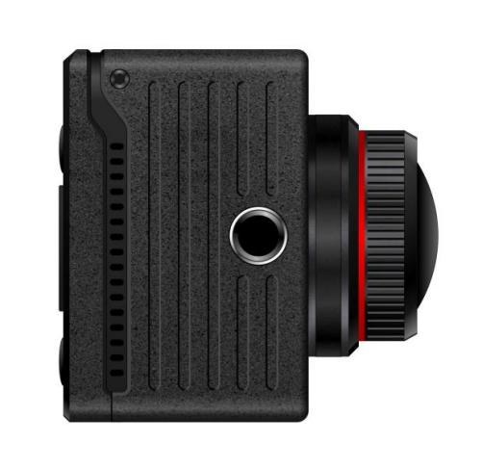

**1**

### **①** **Cooling Intake Vent** 【冷却进气口】

3

4

**②** **Cooling Exhaust Vent** 【冷却排气口】

**③** **Type-C USB2.0 HOST Port (for connecting digital**

**microphones, network cards, etc.)**

**【**Type-C USB2.0 HOST端口（用于连接数字麦克风、

网卡等）】

***相机概述 [Camera Components Overview]***

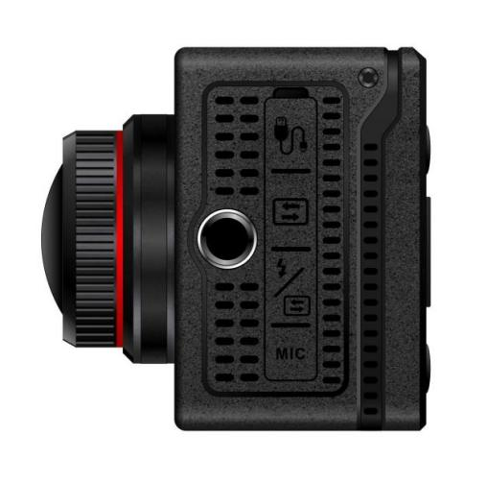

**3**

**4**

**5**

**6**

**2**

***相机概述 [Camera Components Overview]***

**④** **Type-C 3.0 OTG Port (for connecting to a computer for data transfer and UVC function)**

【Type-C 3.0 OTG端口 （用于连接计算机进行数据传输和UVC功能）】

**⑤ Type-C 3.0 OTG Interface &Charging Port**

【Type-C 3.0 OTG接口和充电端口】

**⑥** **3.5mm Microphone / Lavalier Port**

【3.5mm麦克风 / 领夹式端口】

注意：第三个Type-C口是充电口

Caution: The third type-C port is the charging port

顶部、底部和内部 [Top, Bottom, and Interior]

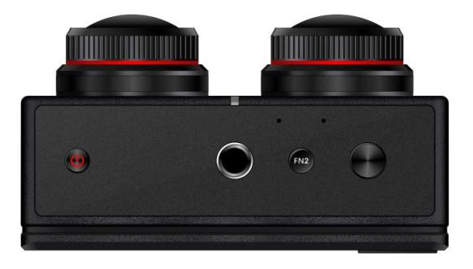

**1**

**3**

**2**

**4**

### **①** **Power Button** 【电源按钮】

**②** **1/4-inch Screw Mount** 【1/4英寸螺丝安装】

**③** **Shutter Button** 【快门按钮】

**④ FN2 keys** 【FN2功能键】

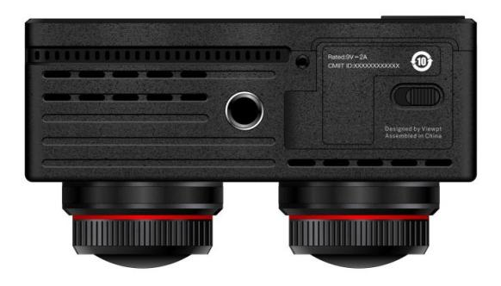

**5**

**6**

**7**

***相机概述 [Camera Components Overview]***

**⑤** **Battery Compartment Switch** 【电池仓开关】

5

6

**⑥** **SD Card Slot** 【SD卡插槽】

**⑦** **Battery Compartment** 【电池仓】

**按钮功能 [Button Functions]**

**● 电源按钮 [Power Button]**

• 按住电源按钮5秒钟可在相机关闭时打开电源。

Press and hold the power button for 5 seconds to power

on the camera when it's off.

• 按住电源按钮5秒钟可在相机开启时关闭相机电源。

Press and hold the power button for 5 seconds to power

off the camera when it's on.

• 如果相机遇到无法正常关机的问题，请按住电源按钮10秒钟以

强制关机。

If the camera encounters an issue preventing a normal

shutdown, press and hold the power button for 10

seconds to force a shutdown.

**● 快门按钮 [Shutter Button]**

• 在“视频”模式下，按下快门按钮开始录制视频。再按一

次可停止录制。

In "Video" mode, press the shutter button to start recording a video. Press it again to stop recording.

• 在“直播”模式下，按下快门按钮开始直播。再按一次可停

止直播。

In "Live" mode, press the shutter button to start a live stream. Press it again to stop the livestream.

• 在“照片”模式下，按快门按钮拍照。

In "Photo" mode, press the shutter button to take a photo.

***相机概述 [Camera Components Overview]***

• 在“预览”模式下，按相册按钮进入相册浏览模式。再按一

次可返回预览模式。

7

8

In "preview" mode, press the album button to enter the album browse mode. Press it again to return to preview mode.



**● 菜单/OK按钮 [Menu/OK Button]**

• 在“预览”模式下，按菜单按钮访问相机的主设置菜单。使用

向上和向下按钮浏览菜单项。再次按下菜单按钮进入子菜单项。

In "preview" mode, press the menu button to access the

camera's main settings menu. Use theup and down

buttons to navigate through menu items. Press the menu

button again to enter sub-menu items.

**● “后退”按钮 [Back Button]**

• 用于在各种界面中导航回上一个屏幕或菜单项。

Used to navigate back to the previous screen or menu item

in various interfaces.



**● 向上按钮 [Up Button]**

• 在“预览”模式下，它访问ISO的快捷方式设置。

In "preview" mode, it accesses shortcut settings for ISO.

• 在主菜单中，它用于上下导航以选择菜单项。

In the main menu, it is used to navigate up and down to select menu items.

• 在相册中，它用作删除文件的快捷方式。

In the photo album, it serves as a shortcut for deleting files.

***相机概述 [Camera Components Overview]***

**● FN1&FN2**

• FN1&FN2功能键暂时未定义，将在后期固件中实现功能。

9

10

The FN1&FN2 function key is currently undefined and will be implemented in later firmware.

**● 左键 [Left Button]**

• 在“预览”模式下，它会访问EV（曝光值）的快捷方式设置。

In "preview" mode, it accesses the shortcut settings for EV

(Exposure Value).

• 在主菜单中，它用于调整参数。

In the main menu, it is used to adjust parameters.

• 在相册中，它用于切换到上一个文件。

In the photo album, it is used to switch to the previous file.

11

12

**● 右键 [Right Button]**

• 在预览模式下，它会访问白平衡的快捷方式设置。

In preview mode, it accesses shortcut settings for

white balance.

• 在主菜单中，它用于调整参数。

In the main menu, it is used to adjust parameters.

• 在相册中，它用于切换到下一个文件。

***相机概述 [Camera Components Overview]***

In the photo album, it is used to switch to the next file.



**视频格式 [Video Formats]**

• VR180格式分辨率：VR180 6K50，VR180 4K50。

VR180 format resolution: VR180 6K50, VR180 4K50.

• 3D格式分辨率：3D 4K60、3D 1080P60。

3D format resolutions: 3D 4K60, 3D 1080P60.

**图像质量设置 [Image Quality Settings]**

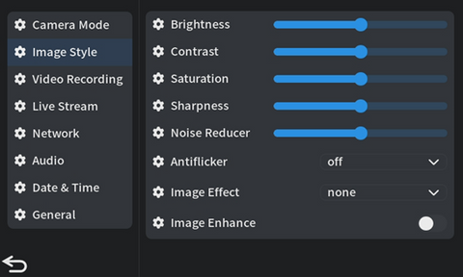

• **图像样式设置：**开机 **->** 点击屏幕右下角的“设置”图标或按“菜单/确定”按钮 **->** 进入菜单 **->** 点击“图像样式” **->** 调整视频的“亮度”、“对比度”、“饱和度”、“锐度”、“降噪器”等设置。

13

14

**Image style settings:** Power on **->** Tap the "Settings" icon in the bottom right of the screen or press the "Menu/OK" button **->** Enter the menu **->** Tap "Image Style" **->** Adjust settings such as "Brightness," "Contrast," "Saturation," "Sharpness," "Noise Reducer," etc. for video.

***如何使用VIEWPT CAM拍摄VR180视频***

***[How to Shoot VR180 Videos with VIEWPT Cam?]***



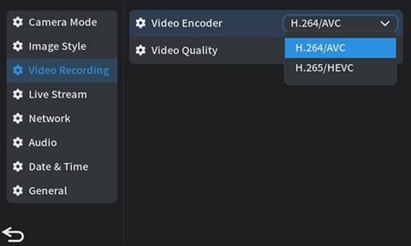

• **基本视频参数设置：**开机 **->** 点击屏幕右下角的“设置”图标

或按“菜单/确定”按钮 **->** 进入菜单 **->** 点击“录制” **->** 在

右侧菜单中，选择“视频编码”和“视频质量”。

**Basic video parameter settings:** Power on **->** Tap the

"Settings" icon in the bottom right of the screen or

press the "Menu/OK" button **->** Enter the menu **->** Tap

''Record" **->** In the right-hand menu, select "video

Encoding" and "Video Quality."

15

16



**1**

**2**

**3**

**4**

**9**

**7**

**8**

**5**

**6**



***如何使用VIEWPT CAM拍摄VR180视频***

***[How to Shoot VR180 Videos with VIEWPT Cam?]***

• **高级参数设置：**使用相机背面的方向键调整专业设置，如“白平

衡”、“ISO”、“EV”、“曝光”等。这些设置的效果将显示在屏幕上。（② 向上键/ISO， ③ 向右键/白平衡， ⑥ 向左键/EV，

⑦ 向下键/EXP）

**Advanced parameter settings:** Use the directional keys on the back of the camera to adjust professional settings such as "White Balance," "ISO," "EV," "Exposure," etc. The effects of these settings will be displayed on the screen.

(② for Up/ISO, ③ for Right/White Balance, ⑥ for Left/EV (Exposure Value), and⑦ for Down/Exposure Settings)

**录制和浏览 [Recording & Browsing]**

***如何使用VIEWPT CAM拍摄VR180视频***

***[How to Shoot VR180 Videos with VIEWPT Cam?]***

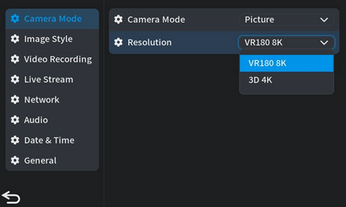

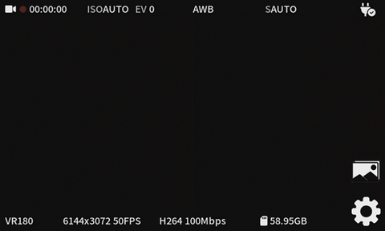



• **录制：**开机 **->** 点击屏幕右下角的“设置”图标或按“菜单/确定”按钮 **->** 进入菜单 **->** 点击“相机模式” **->** 在右侧菜单中，从“相机模式”的下拉菜单中选择“视频” **->** 从下拉菜单中选择适当的视频格式（VR180 / 3D） **->** 完成基本视频录制设置后， 按下相机的“返回”按钮 **->** 视频录制图标将显示在屏幕的左上角，表示您可以开始拍摄VR180或3D视频。

**Recording:** Power on **->** Tap the "Settings" icon in the bottom right of the screen or press the "Menu/OK" button **->** Enter the menu **->** Tap "Camera Mode" **->** In the right-hand menu, select "Video" from the dropdown menu of "Camera Mode" **->** Choose the appropriate video format (VR180/3D) from the drop-down menu **->** After completing the basic video recording settings, press the camera's "Back" button **->** The video recording icon will be displayed in the top left corner of the screen, indicating that you can start shooting VR180 or 3D video.

17

18



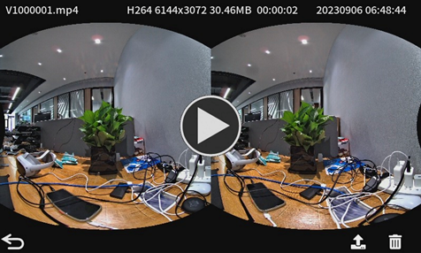

19

20



**1**

**2**

**3**

**4**

**9**

**7**

**8**

**5**

**6**

• **要浏览和播放拍摄的视频：**点击屏幕右下角的“图像”图标或按相册按钮（①）。

**To browse and play the captured videos:** Tap the "Image" icon located in the bottom right corner of the screen or press the album button (①).

***如何使用VIEWPT CAM拍摄VR180视频***

***[How to Shoot VR180 Videos with VIEWPT Cam?]***

• **上传：**在相册页面上，单击“向上”按钮（②）或屏幕上传图标进行上传。



**To upload:** On the album page, click the "Up" button (②) or the screen upload icon to upload.

注意：确保SD卡已插入照相机并具有足够的存储空间。

Caution:Ensure that an SD card is inserted into the camera and has sufficient storage space.

**直播格式 [Live Stream Format]**

**●** 支持VR180格式的6K50和4K50分辨率。

Supports both 6K50 and 4K50 resolutions in VR180 format.

**● 连接设置 [Connection Settings]**



**3**

**4**

**5**

**6**

**2**

***如何使用VIEWPT CAM在VR180中进行直播***

***[How to Live Stream in VR180 with VIEWPT Cam?]***

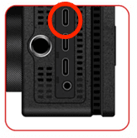

• **连接Type-C：**用Type-C端口（③）

插入网卡，连接到有线网络，相机

开机后会自动识别网卡。

**Connect Type-C:** Plug in the NIC with

Type-C port (③), connect to the wired

network, the camera will automatically

identify the network card after power on.

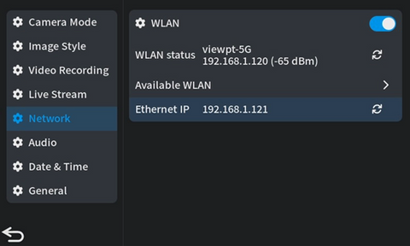

• **连接WIFI：**打开相机电源 **->** 单击屏幕右下角的“设置”图标“菜单/确定”按钮 **->** 进入菜单项 **->** 单击“网络” **->** 打开右侧菜单“WLAN”开关 **->** 单击“可用WLAN” **->** 选择所需的WIFI并完成连接。



**Connect WIFI:** Power on the camera **->** click the "Settings" icon in the bottom right of the screen or "Menu/Ok" button **->** enter the menu item **->** click "Network" **->** open the right menu "WLAN" switch **->** click "Available WLAN" **->** select the WIFI you need and finish the connection.

21

22

**视频参数设置 [Video Parameter Settings]**



• 打开相机电源 **->** 单击屏幕右下角的“设置”图标或按“菜单/

确定”按钮 **->** 导航到菜单项 **->** 单击“图像样式” **->** 调整视

频的“亮度”，“对比度”，“饱和度”，“清晰度”和“3D降噪”。

Power on the camera **->** click the "Settings" icon in the

bottom right of the screen or press the "Menu/Ok"

button **->** navigate to the menu item **->** click "Image

Style" **->** adjust the video's "Brightness," "Contrast,"

"Saturation," "Sharpness," and "3D Noise Reduction."



**1**

**2**

**3**

**4**

**9**

**7**

**8**

**5**

**6**

• **高级参数设置：**通过右侧相机背面的方向键调整专业设置（“白平

***如何使用VIEWPT CAM在VR180中进行直播***

***[How to Live Stream in VR180 with VIEWPT Cam?]***

衡”、“ISO”、“EV”、“曝光”等）。这些设置的效果将显示在屏幕上。（② 向上键/ISO，③ 向右键/白平衡，⑥ 向左键/EV，

⑦ 向下键/EXP）



**Advanced parameter settings:** Adjust the professional settings ("white balance," "ISO," "EV," "exposure" and others) through the direction keys on the back of the camera at the right side. The effects of these settings will be displayed on the screen.

(②for Up/ISO, ③for Right/EV (Exposure Value), ⑥for Left/White Balance, and⑦for Down/Exposure Settings)

23

24

**直播设置 [Live Streaming Settings]**

• 点击屏幕右下角的“设置”图标 **->** 进入菜单项 **->** 点击“直播”

**->** 选择并调整“视频编码”、“比特率”和“GOP”相关参数。

Click the "Settings" icon in the bottom right of the screen **->**

enter the menu item **->** click "Live Streaming" **->** select and

adjust the "Video Encoding," "Bit Rate," and "GOP"related parameters.

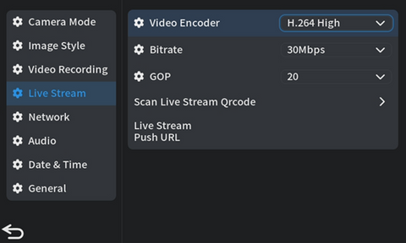

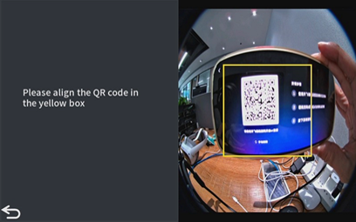

***如何使用VIEWPT CAM在VR180中进行直播***

***[How to Live Stream in VR180 with VIEWPT Cam?]***

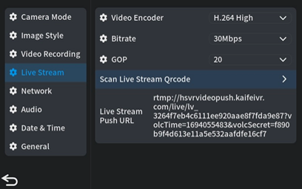



25

26

• 点击“直播”菜单中的“扫描直播二维码” **->** 将APP中的二

维码放入黄色框中 **->** 如果成功，将自动返回“直播”菜单 **->**

“直播链接”会出现在直播地址右侧 **->** 点击相机“后退按钮”

**->** 显示屏左上角显示照片拍摄图标 **->** 点击相机“拍摄按钮”

开始直播。

Click "Scan Live QR Code" in the "Live" menu **->** Put the QR

code in VIEWPT App into the yellow box **->** if successful, it

will automatically return to the "Live" menu **->** "Live

Streaming Link" will appear on the right side of the

streaming address **->** click the camera "back button"**->** the

top left corner of the display wil show the photo shooting

icon **->** click the camera "shooting button" to start live

streaming.

***如何使用VIEWPT CAM在VR180中进行直播***

***[How to Live Stream in VR180 with VIEWPT Cam?]***



注意 [Notes]：

• 请确保具有C型接口的NIC（网络接口卡）连接到第一个C型

端口。或者，您可以通过WiFi连接到互联网，确保足够的带宽，速度和信号稳定性。在实际直播中，建议只保持一种类型的连接，以保证数据传输的稳定。

Please ensure that the NIC (Network Interface Card) with a Type-C interface is connected to the first Type-C port. Alternatively, you can connect to the internet via WiFi, ensuring sufficient bandwidth, speed, and signal stability. During actual live broadcasting, it is advisable to maintain only one type of connection to guarantee stable data transmission.

• 请注意，目前不支持3D格式的直播。

Please note that 3D format live streaming is not currently supported.

27

28

**UVC格式 [UVC format]**

• 支持VR180 6K50分辨率。

Support VR180 6K50 resolution.

**画质设置 [Picture Quality Settings]**



• 打开相机电源 **->** 单击屏幕右下角的“设置”图标或按“菜单/

确定”按钮 **->** 进入菜单 **->** 单击“图像” **->** 调整照片参数

的设置，例如“亮度”、“对比度”、“饱和度”、“锐度”、“3D降

噪”和任何其他相关选项。

Power on the camera **->** click the "Settings" icon in the

bottom right of the screen or press the "Menu/Ok" button

**->** enter the menu **->** click "Image" **->** Adjust settings for

photo parameters such as "Brightness," "Contrast,"

"Saturation," "Sharpness," "3D Noise Reduction," and any

other relevant options.



**1**

**2**

**3**

**4**

**9**

**7**

**8**

**5**

**6**

• **专业参数设置：** 使用相机屏幕以外的方向键调整“白平衡”、

***了解更多关于VIEWPT CAM中的UVC功能的信息***

***[Get to Know More about UVC Function in VIEWPT CAM]***

“ISO”、“曝光值（EV）”等专业设置。进行这些调整后，预览效

果将在PC 终端上可见。（② 向上键/ISO，③ 向右键/白平衡，

⑥ 向左键/EV，⑦ 向下键/EXP）



**Professional parameter settings:** Adjust professional settings such as "White Balance," "ISO," "Exposure Value (EV)," and other professional parameters using the directional keys besides the screen of the camera. The preview effect will be visible on the PC terminal after making these adjustments.

(② for Up/ISO, ③ for Right/White Balance, ⑥ for Left/EV (Exposure Value), and ⑦ for Down/Exposure Settings)

29

30

**功能预览 [Function Preview]**

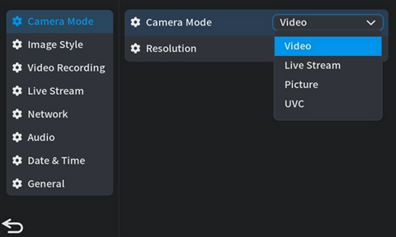

• 打开相机电源 **->** 单击“设置”图标或按屏幕右下角的“菜单/

确定”按钮 **->** 进入菜单 **->** 单击“模式” **->** 右侧菜单中，从

“相机模式”的下拉菜单中选择“UVC” **->** 从“分辨率”下拉菜单

中选择默认的VR180 6K50分辨率 **->** 按下相机的“返回”按钮

**->** 将USB 2.0电缆连接到PC。

Power on your camera **->** click the "Settings" icon or press

the "Menu/Ok" button at the bottom right of the screen **->**

enter the menu **->** click "Mode" **->** in the right menu, select

"UVC" from the drop-down menu for "Camera Mode." **->**

choose the default VR180 6K50 resolution from the

drop-down menu for "Resolution." **->** press the camera's

"Back" button **->** connect the USB 2.0 cable to the PC.

• **在PC上设置直播软件（以OBS为例）：**打开OBS **->** 源 **->** 添加

源“+”**->** 视频采集设备 **->** 新建 **->** 从设备列表中选择“VR180

相机” **->** 分辨率/帧速率，选择“自定义”**->** 将分辨率设置为

31

32

“6144x3072”**->** 为FPS选择“匹配输出帧速率（自动选择：50）”。

**Setting Up Live Streaming Software on PC (Taking OBS as an Example):** Open OBS **->** Source **->** Addsource"+" **->** Video capture device **->** New **->** Select "VR180 Camera" from the device list ->For Resolution/Frame Rate, choose "Custom" **->** Set the resolution to "6144x3072" **->** Select "Match output frame rate (auto-select: 50)" for FPS.

***了解更多关于VIEWPT CAM中的UVC功能的信息***

***[Get to Know More about UVC Function in VIEWPT CAM]***

注意 [Notes]：

• 功能只能通过相机三个Type-C接口中的中间（第二个）Type-C接口使用。

The UVC function can only be used throughthe middle (the second) Type-C interface among the camera's three Type-C interfaces.

• 避免在UVC功能激活时切换相机模式。

Avoid switching the camera mode when the UVC function is active.

• iOS系统不支持UVC下的H.264，使其与Apple系统不兼容。

The iOS system does not support H.264 under UVC, making it incompatible with Apple systems.

• 为了保证UVC功能下的高质量、高分辨率、高码率的3D视频，请考虑以下建议：

To ensure high-quality, high-resolution, and high-bitrate 3D video under the UVC function, consider the following suggestions:

①检查PC软件中的硬件解码。

Check for hardware decoding in your PC software.

②确保你的电脑具有具有8K解码功能的显卡。

Ensure your PC has a graphics card with 8K decoding capabilities.

③使用高质量的USB 2.0连接，并保持数据线尽可能短。

Use a high-quality USB 2.0 connection, and keep the data cable as short as possible.



**照片格式 [Photo Formats]**

• 支持VR180 8K和3D 4K格式和分辨率。

Supports both VR180 8K and 3D 4K formats and resolutions.

**图像质量设置 [Image Quality Settings]**



• 打开相机电源 **->** 单击屏幕右下角的“设置”图标或按“菜单”

按钮 **->**进入菜单项 **->** 单击“图像样式” **->** 调整“亮度”，

“对比度”，“饱和度”，“清晰度”，“3D降噪”和任何其他相关参

数的照片设置。

Power on the camera **->** click the "Settings" icon in the

bottom right of the screen or press the "Menu" button **->**

enter the menu item **->** click "Image Style" **->** adjust the

photo settings for "Brightness," "Contrast," "Saturation," "Sharpness," "3D Noise Reduction," and any other

relevant parameters.

33

34



**1**

**2**

**3**

**4**

**9**

**7**

**8**

**5**

**6**

• **高级参数设置：**要调整“白平衡、“ISO”、“曝光值（EV）”等专业设置，请使用位于右侧的相机背面的方向键。这些设置的效果将显示在屏幕上。（② 向上键/ISO，③ 向右键/白平衡，⑥ 向左键/EV，⑦ 向下键/EXP）

***如何使用VIEWPT CAM拍摄VR180或3D格式的照片***

***[How to Take VR180 or 3D Photos with VIEWPT CAM?]***



**Advanced parameter settings:** To adjust professional settings such as "White Balance," "ISO," "Exposure Value (EV)," and others, use the directional keys on the camera's back, located on the right side. The effects of these settings will be displayed on the screen.

(② for Up/ISO, ③ for Right/White Balance, ⑥ for Left/EV (Exposure Value), and ⑦ for Down/Exposure Settings)

**照片参数设置 [Photo Parameter Settings]**

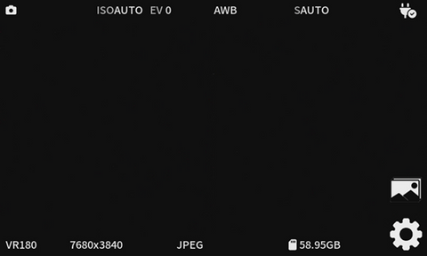 • 打开相机电源 **->** 单击屏幕右下角的“设置”图标或按“菜单/确定”按钮 **->** 进入菜单项 **->** 单击“模式” **->** 右侧菜单中，从“相机模式”的下拉菜单中选择“照片” **->** 从“分辨率”下拉菜单中选择适当的分辨率 **->** 完成照片拍摄的基本设置 **->** 完成照片拍摄的基本设置后， 按下相机的“后退按钮”显示屏左上角 **->** 显示照片拍摄图标 **->** 点击相机的“拍摄按钮”开始拍摄照片。

Power on the camera **->** click the "Settings" icon in the bottom right of the screen or press the "Menu/Ok" button **->** enter the menu item **->** click "Mode" **->** in the right menu, select "Photo" from the drop-down menu for "Camera Mode" **->** choose the appropriate resolution from the drop-down menu for "Resolution" **->** complete the basic settings for photo shooting **->** after completing the basic settings for photo shooting, press the camera's "back button" **->** the upper left corner of the display shows the photo shooting icon **->** click the camera's "shooting button" to start shooting photos.

***如何使用VIEWPT CAM拍摄VR180或3D格式的照片***

***[How to Take VR180 or 3D Photos with VIEWPT CAM?]***

35

36





• 要浏览和播放拍摄的照片，请点击屏幕右下角的“图像”图标或

按相册按钮。

To browse and play the captured photos, tap the "Image"

icon in the bottom right of the screen or press the album

button.

• 在相册页面上，单击向上按钮或屏幕上传按钮进行上传。

On the album page, click the up button or the screen

upload button to upload.

注意 [Notes]：

• 确保SD卡已插入相机并有足够的存储空间。

Make sure the SD card is inserted into the camera and has enough storage space.

37

38

***如何使用VIEWPT CAM拍摄VR180或3D格式的照片***

***[How to Take VR180 or 3D Photos with VIEWPT CAM?]***

